015B
Abstract
Charcot-Marie-Tooth is a hereditary motor and sensory disorder that produces significant foot and ankle deformities. Various outcomes are reported with surgical treatment of this deformity due to the myriad of procedures proposed. Complications in the management of this deformity can be lessened by proper identification and treatment of the neuromuscular etiology of this disorder. The objective of this study is to report our comprehensive soft tissue reconstruction for treatment of the Charcot-Marie-Tooth cavovarus foot. Eight feet had a comprehensive soft tissue reconstruction performed in six patients (3 female, 3 male). The average patient age was 16.0 years (range, 7-46 years). All patients were diagnosed with Charcot-Marie-Tooth disorder prior to surgery. Mean follow up time after surgical intervention was 2.7 years (range, 1-6.8 years). After surgical correction there was a statistically significant radiographic decrease in the metatarsal pitch angle (P=0.008), calcaneal pitch angle (P=0.004) on the lateral view, and the talo-first metatarsal angle (P=0.008) on the anterior posterior view. A statistically significant lateral shift in the tibial-calcaneal distance (P=0.003) was found on the axial radiographic view. The most common complication experienced was a plantar incision wound dehiscence, all treated successfully with local wound care. Our comprehensive soft tissue reconstruction proved to be a viable procedure to realign the CMT cavovarus foot and ankle deformity.
Level of Evidence: Level III

Introduction
Cavovarus foot deformity negatively impacts a patient’s quality of life and inhibits their ability to perform daily activity. Approximately 80% of cavovarus foot deformities can be attributed to neurological disorders. The most common cause is Charcot-Marie-Tooth (CMT) disease (also known as hereditary motor sensory neuropathy) (1). Two forms of CMT have been classified; the hypertrophic form (Type I) and the neuronal form (Type II) are both autosomal dominant with variable expressivity (2,3). Patients with Type I disease have a marked slowing of conduction velocity of motor nerves, and a cavovarus deformity generally develops early in the second decade of life because of progressive atrophy of the intrinsic muscles; later involving the calf muscles. Motor nerve conduction velocities are abnormal in all patients even before the deformity manifests. Sensory nerve potentials are abnormal in all patients even if there are no clinical signs of sensory loss. Although the disease is progressive, the nerve conduction velocities do not continue to decrease with time (4). Patients who have Type II disease, have normal motor nerve conduction, and the clinical onset generally is in the third decade of life.
The cavovarus deformity in CMT is a direct result of weakness of the intrinsic muscles of the foot, tibialis anterior, and peroneus brevis (3,4,5). Common features of this disorder include distal muscle imbalance with onset anywhere from the first to fourth decades in life, decrease or absent deep tendon reflexes, mild distal sensory loss, decreased motor and sensory nerve conduction velocity in peripheral nerves, enlargement and firmness of peripheral nerves in most patients and segmental nerve demyelinization with axonal atrophy and onion bulb formation in the distal nerves (1,2,3,4,6,7). On examination of a patient with CMT a cavovarus foot consists of hindfoot varus, marked cavus foot deformity, and forefoot valgus, from the accentuated declination of the first ray relative to the lesser rays (8). Initially, the forefoot, midfoot, and hindfoot deformity is supple, but in time, progresses to a fixed deformity with secondary bone and soft tissue adaptation (1,3,7,8,9). Many patients lose their ability to walk with this progressive deformity if left untreated (2). Because of the functional impairment of this disease the psychological problems also play a role in a reduction in the quality of life (6).
Many non-surgical and surgical treatments have been described for CMT. Current non-surgical treatment includes night splints to prevent or minimize the development of fixed osseous deformities, extra depth shoes to accommodate clawtoes, custom orthotic devices to help distribute weight across the plantar foot and the varus heel position and ankle-foot orthosis to attempt toward the control foot drop (7,8,9). In general, conservative treatment has been unsuccessful in correcting or preventing progression of this deformity (8,9,10). Surgical procedures can be categorized into three groups; 1) soft tissue procedures including plantar fascia release, achilles tendon lengthening, various tendon transfers and releases, 2) bony procedures such as, calcaneal, metatarsal, and tarsal osteotomies and arthrodesis, and 3) combinations of both (1,10). There is no single procedure that can be applied to all cavus foot deformities. Surgery in the past has consisted of triple arthrodesis and attempts to stabilize the feet with a better weight bearing mechanism. With this procedure at least three joints are fused, leaving a shortened rigid foot (7). It is important that treatment must be individualized and no single surgical solution will meet the needs of every patient (8).
Treatment has been inconsistently successful because of the lack of understanding of the pathomechanics of this deformity (9). The weak tibialis anterior is opposed by the strong peroneus longus, which causes plantar flexion of the first ray (cavus) and a forefoot pronation. In addition the weak peroneus brevis is being overpowered by the strong tibialis posterior, which creates an inversion of the subtalar joint (8,9,10). Secondary problems result from first ray plantar flexion which leads to hind foot varus in order to compensate for forefoot pronation in stance phase. Dynamically, the heel varus places the ankle at increased risk for lateral ankle inversion type injuries and increases the plantar pressures on the lateral boarder of the foot.
Main indications for surgical treatment are gait problems, ankle instability, plantar ulcerations caused by high contact pressures in a sensory impaired foot, and difficulties in shoe wear (1,2,3,4,6,7,10). Mosca described principles that can help guide treatment by; correcting all segmental deformities while preserving joint motion, balancing the remaining muscle forces and leaving reasonable treatment options for possible recurrence of deformity and pain (11). Soft tissue procedures are rarely performed alone and noted to not offer significant lasting benefit (21), but can correct longstanding contracture, augment weak muscles and correct muscle imbalances (12). Appropriate tendon transfers, achilles tendon lengthening and/or posterior capsule release should be employed when indicated, but only after correction of the foot and ankle has been achieved (9). Joint preserving osteotomies with tendon transfers are performed when complete reduction of the deformity is not attained after soft tissue release alone in order to prevent or delay arthrodesis. Realignment arthrodesis procedures are needed to correct the severe rigid foot (12).
The purpose of our study is to report our unique comprehensive soft tissue surgical approach to the treatment of Charcot-Marie-Tooth foot deformities.
Methods
Our institutional review board approved this retrospective study. We conducted a chart and radiographic review on 8 feet in 6 patients with a documented diagnosis of Charcot-Marie-Tooth disease who underwent a comprehensive soft tissue release between 1997 and 2010. Each patient was identified and assessment parameters were obtained from the medical records. For each patient pre and post operatively; all demographic, radiographic, and clinical measurements were recorded and averaged. Medical records were reviewed to determine patient’s age, sex, height, weight, body mass index (BMI), history of prior treatment, date of surgery, subsequent procedures preformed, date of repeat surgery, and postoperative complications.
Standard weight-bearing hindfoot alignment (axial) views (13,14,15), foot and ankle anterior-posterior (AP), medial-oblique (MO) and lateral radiographs were obtained for each subject. On the AP radiograph the talo-first metatarsal angle, kite angle, hallux abuctus angle, and engle angle were measured. The talo-first metatarsal (Meary), anterior distal tibial angle (ADTA), tibio-talar, tibio-calcaneal, metatarsal and calcaneal pitch angles were measured on the lateral radiograph of the foot. Translation of the midline of the calcaneus as compared to the tibial anatomic axis was determined from the hindfoot alignment (axial) radiographic view (13,14,15). All angular measurements were measured using a goniometer to the degree by one investigator (JSA).
Statistical Methods
SPSS 17.0 (______) was used to collect and analyze all data. Descriptive statistics were used to calculate mean and ranges. Differences between groups were evaluated using chi-square and t-test for equality of means. A p-value of 0.05 or less was considered statistically significant.
Surgical Technique
The extent of surgery to correct the cavovarus deformity depends on the degree and chronicity of the deformity.. The order of surgical release is predicated on the goal of establishing hindfoot correction, forefoot correction, and then finally tendon/muscle rebalancing. The correction is obtained by first releasing ligamentous originated deformities, then performing any warranted tendon and/or muscle transfer and/or lengthening procedures to balance the biomechanics of the foot and ankle. Ligamentous releases consist of a complete plantar fasciectomy, long plantar, short plantar, plantar calcaneonavicular (spring) ligaments (as described by Tachnijan), and tarsal tunnel decompression. Then tendon and/or muscle balancing may be achieved with one or more of the following procedures: lengthening of the posterior muscle group, lengthening of the peroneus longus, transfer of the extensor halluces longus (Jones procedure), and transfer of the posterior tibial tendon through the interosseous ligament. As alluded to earlier, the aforementioned procedures are patient specific; thus, the following paragraphs outline the indications for each specified procedure with respect to the cavovarus foot deformity resulting from Charcot-Marie-Tooth.

Flexor hallucis longus, flexor digitorum longus

In a cavus foot deformity, the plantar fascia is a tight and persistent deforming force. As a result, a radial plantar fascial release is performed to correct the pronation of the forefoot and the plantar flexed first metatarsal. Tachdjian described a full thickness incision to the sole of the foot, extending from the distal part of the third metatarsal proximally towards the central calcaneus, followed by a complete excision of the contracted plantar fascia and releases of the origins of the abductor hallucis muscle, abductor digiti quinti, the long and short plantar ligaments, and the plantar calcaneonavicular (spring) ligament (18). If this correction causes excessive flexion of the digits, then selective intramuscular recessions of the long flexor tendons may be performed by extending a concomitant tarsal tunnel incision (4,9,18). Careful dissection must be done when excising the entire plantar fascia as the medial and lateral plantar nerve lie just deep to the plantar fascia (18).
As previously reported, significant corrections of cavovarus deformities may cause excessive pressure to the medial ankle neurovascular bundle leading to acute or subacute tarsal tunnel syndrome; thus, a prophylactic tarsal tunnel release may be warranted (17). The author’s prefer a linear skin incision orientated 10° from the perpendicular plantar surface of the foot. Once the superficial fascia of the leg and deep fascia are identified, a release is performed proximally by advancing a fasciotome. The release is further extended proximally to the distal level of the gastrocnemius muscle. In addition, the superficial and deep fascia of the abductor hallucis muscle are released and is performed parallel to the medial and lateral plantar nerves. The final release is achieved by anchoring fascia of the abductor hallucis muscle as it inserts into the calcaneus, dividing the medial and lateral plantar nerve tunnels (17). Utilizing this approach allows for a complete surgical release of the tarsal tunnel and the plantar medial and lateral tunnel.
At the ankle, the extensors and the tibialis anterior are weaker than the ankle plantarflexors. This imbalance creates a footdrop and a contracted Achilles tendon, which may require heel-cord lengthening (8). We prefer the Bauman procedure that involves intramuscular lengthening of the gastrocnemius and soleus; theoretically this preserves muscle strength of the posterior muscle group as compared to an Achilles tendon lengthening (16).
The Bauman procedure incision is made two finger’s breadth posterior to the posterior medial edge of the tibia. A 4 to 8 cm longitudinal medial incision is placed at the mid-calf level between the junction of the gastrocnemius and soleus muscle bellies. Blunt dissection is used to avoid the greater saphenous vein and nerve as it courses through this area, which are then retracted. The cural fascia is identified and divided to expose the gastrocenemius muscle. The plane between the gastrocnemius and soleus muscle bellies are separated bluntly. The plantaris tendon is identified and transected. While tension is placed on the gastrocnemius muscle by maximally dorsiflexing the ankle joint with the knee extended, a blade is used to make a parallel incision completely across the deep fascia, The incision is made in the tendinous portion of the gastrocnemius muscle until a normal Silfverskiöld test is achieved (16).
Abnromal plantarflexion of the first ray caused by excessive pull of the peroneus longus at its insertion site is a common finding in cavovarus feet. The deforming force of the peroneus longus leads to a decrease in eversion ankle strength. The authors’ prefer either a peroneus longus tendon lengthening or transfer to peroneus brevis. Any remaining attachments of the peroneus longus distally should be released.
Clawtoe deformities are somewhat improved after the midfoot and hind foot deformities are corrected. If the digital deformities continue to be a problem after cavus foot correction they can be addressed at a second surgery. If the lesser digits are flexible, then a flexor to extensor tendon transfer can aid in correction. If the deformity is rigid then fusion of the middle and proximal phalanx with pin or internal fixation can correct the deformity. The EHL is commonly preserved and used as an accessory ankle dorsiflexor and patients can develop a cock-up deformity of the first metatarsal phalangeal joint (19). If there is clawing of the hallux, an extensor hallucis longus recession (Jones procedure) is also performed. The author’s perform an arthrodesis of the interphalangeal joint of the hallux with a transfer of the extensor hallucis longus tendon to the neck of the first metatarsal. The EHL is identified at the level of the distal interphalangeal joint (IPJ) and transected. A secondary dorsal incision is made at the first metatarsal phalangeal joint, at this incision the EHL tendon can be pulled out of the distal hallux. Attention is then directed at the IPJ where the base of the distal phalanx and the head of the proximal phalanx is resected. Once all articular cartilage is removed fixation can be inserted to stabilize the interphalangeal fusion. A 3.2mm drill bit is used medial-dorsal to lateral-plantar in the first metatarsal head to make a path for the EDL. The EHL tendon is then pulled through in the same manner in the first metatarsal and re-sutured back onto itself using a Pulvertaft interweave technique (20).
Significant weakness of the dorsiflexors of the foot and ankle is commonly seen with a marked foot drop gait. The tibialis posterior normally remains very strong and is a pathogenic force in the cavovarus deformity. Anterior transfer of the posterior tibial tendon to the lateral cuneiform is done in order to prevent progressive varus deformity of the hindfoot, and to balance the weak peroneal and overcome dorsiflexion weakness. The tibialis posterior tendon is released from the navicular and the other plantar attachments. The released tibialis posterior tendon is pulled out of the distal medial incision and passed subcutaneously to the proximal medial incision used for the Bauman procedure. A 4-6 cm anterior lateral distal leg incision is made and dissected down to the interosseous membrane. A window is then cut in the interosseous membrane where the tibialis posterior tendon is passed through. Distally the tibialis posterior tendon is passed subcutaneously through a distal lateral incision to the dorsum of the foot and passed through a hole drilled in the lateral cuneiform. A bio-tenodesis screw (Arthrex, Inc.) is sized and placed under maximum tension.
A well padded short leg cast is applied with the ankle in neutral position, and the patient is non-weight bearing for six weeks. The cast and button are removed approximately 6 weeks postoperatively, followed by gradual protected partial weight bearing in a walking boot for 6 weeks along with aggressive physical therapy for a total of at least three months. Full weight bearing is allowed in a hinged Ankle Foot Orthosis (AFO) with a plantarflexion stop at 3 months postoperatively where the patient can wear a normal shoe again. (Figures 1-7)

Results
A total of eight comprehensive soft tissue reconstructions were performed in six patients (3 female, 3 male). Two out of the six patients underwent bilateral procedures at separate intervals. All patients were previously diagnosed with Charcot-Marie-Tooth and had significant pain and cavovarus foot deformity. The mean patient age was 16.0 years (range, 7-46), height of 152.2 cm (range, 127-193), weight of 48.1 kg (range, 22.1-81) and BMI of 19.6 (range, 12.5-30.7) (Table 1). Only two patients had a history of prior surgical treatment. Four out of the eight feet returned to the operating room for additional surgical intervention after their initial postoperative course. Three feet underwent a reverse Jones procedure and one underwent a flat foot reconstruction for overcorrection. Three out of eight feet presented with plantar incision wound dehiscence complications, which resolved with daily local wound care. Average postoperative follow up from the time of surgery was 2.6 years (range, 1-6.8). The short minimum follow up time after surgery can be attributed to the proximity of this analysis and the subject’s surgical date.
A significant difference was observed for radiographic angular measurement when comparing pre and postoperative values. On the lateral weight bearing radiographic view a statistically significant difference between pre and post operatively was found in the metatarsal pitch angle (P=0.008) and the calcaneal pitch angle (P=0.004) (Table 2); after patients underwent surgical correction there was a decrease in the pitch angles postoperatively. Thus the arch height decreased postoperatively with a decrease in the talo-first metatarsal angle. On the AP weight bearing view a statistically significant difference was found between pre and postoperative talo-first metatarsal angle (P=0.008). On the axial radiographic (hindfoot alignement) view a statistically significant difference was found between pre and postoperative tibial-calcaneal distance (P=0.003). Thus the position of the midline of the calcaneus was significantly lateralized by the surgical procedure (Table 3).
Discussion
Characteristically, muscle involvement in CMT progresses from distal to proximal and are accepted to be the result of motor imbalance. The muscles primarily affected are the intrinsic muscles of the foot, tibialis anterior, and peroneus brevis. The strong antagonists such as the long extensors, peroneus longus, and tibialis posterior, overpower the weakened muscles resulting in a cavovarus foot (12). Ankle dysfunction is due to the weakness of the tibialis anterior. The first ray becomes plantarflexed with a weak tibialis anterior and a strong peroneus longus. This will overtime produce a hindfoot varus deformity that develops passively, secondary to the forefoot cavus from the first ray plantarflexion (forefoot driven hindfoot varus). The tibialis posterior overpowering will also contribute to the varus hindfoot in the face of a weakened peroneus brevis. Forefoot deformities appear to develop after loss of the function of the intrinsic muscles and imbalance of the extrinsic muscles. Lesser digital clawing develops after the intrinsic function of plantarflexion of the metatarsophalangeal joints and interphalangeal extension is lost. Sparing of the extensor hallucis longus can be observed, which contributes to the clawed hallux. CMT generally has a fixed anterior cavus at the level of the midfoot with or without a rigid hindfoot (3,10,21). A reducible deformity will determine the appropriate procedure for surgical correction. The hindfoot can be assessed with the use of the Coleman block test. This requires the patient to stand on a block of wood with the heel and the lateral forefoot supported by the block, which allows the plantarflexed first ray to drop. If the deformity is flexible, the heel will correct to neutral or slight valgus. This finding would suggest that eliminating the forefoot valgus should correct the hindfoot malalignment. If the hindfoot alignment does not change, then the hindfoot position is fixed and will not change with forefoot repositioning alone. Therefore, the Coleman block test assists in determining the decision for the level(s) for surgical treatment (8,21,22).
In the past many patients have undergone triple arthrodesis, which was previously considered to be a definitive procedure to create a well-aligned and functional foot. However, long-term studies have shown a high incidence of osteoarthritis of the adjacent joints (1). The cavovarus deformity largely involves the forefoot and to a lesser extent the midfoot and hind foot. Therefore, it is advisable to direct the major correction to the forefoot and leave the midfoot and hind foot joints mobile (7). Recurrent hindfoot varus is one of the major causes of treatment failure. Loss of correction has been observed in patients with CMT even when the hindfoot was fused. Prevention of recurrent varus remains a treatment challenge (1,2). The data in our study demonstrated a statistical significant difference in pre and post operative heel alignment and maintenance of the corrected cavovarus foot deformity over our short-term follow up.
In a radiographic study by Aktas et. al, twenty-six patients older than 10 years who had no previous foot surgery where measured on lateral standing radiographs (5). The tibio-talar and tibio-calcaneal angles were measured and used to evaluate hindfoot position. Normal values are 110° for the tibio-talar angle and 68° for the tibio-calcaneal angle (4,5). In their group of CMT patients, the tibio-talar angle was measured at 94.4° and the tibio-calcaneal angle measured 58.4°, indicating that in weight bearing the hindfoot is in significant dorsiflexion in CMT patients as compared to normal. The dorsiflexion occurs through the ankle joint since the talocalcaneal relationship is normal. They suggest that since the hindfoot is in dorsiflexion, achilles tendon lengthening is contraindicated in most CMT patients and will only serve to reduce the power of the triceps surae in the stance phase, which will have adverse effects on gait, and worsen the deformity by allowing increased hindfoot dorsiflexion (5). In our multiplanar radiographic observation, forefoot cavus creates ankle dorsiflexion and hindfoot varus. Although the lateral tibial-talar angle remained unchanged in our study, however a trend was shown toward an increase angle which means a slight decrease in equinus which maybe masked by the varus rotation of the calcaneus.
Ward et al. besides releasing the plantar fascia, transfers the peroneus longus to the peroneus brevis (1). They believe the deformity is driven by a plantarflexed first ray as described by Paulos et al. (23). Removing this deforming force on the first ray reinforces the weak eversion strength of the peroneus brevis. We feel our technique of lengthening of the peroneus longus has a similar result whereby effectively strengthens the peroneus longus. Ward et al. also stated that if the tibialis anterior is at least a grade strength of 4 or 5, the tendon is transferred to the lateral cuneiform to supplement eversion strength. They believe this transfer decreases the cavus foot deformity and foot inversion while preserving the foot dorsiflexion function (1). Our technique preserves the normal function of the already weaker tibialis anterior tendon and rely on it’s function to balance the effect of the posterior tibial tendon transfer.
Surgical procedures in the past all proposed for treatment of CMT, used resection of bone or osteotomies to obtain correction (9). Many have often failed to take into account tight, contracted plantar structures, muscle imbalance, or fixed varus deformity of the hindfoot. The results of these surgical procedures are difficult to evaluate and compare mainly because of the variety and combinations of procedures, and the lack of uniformity in outcome criteria (8,10).
The recent trend towards joint sparing procedures is driven by an appreciation that the degree of deformity correction can be achieved through an osteotomy and an acknowledged concern about adjacent joint arthritis related to arthrodesis (21). If a plantar grade foot cannot be obtained with osteotomies or soft tissue releases then a triple arthrodesis may be unavoidable and can give satisfactory results. Wetmore et al. suggested that given time, triple arthrodesis will fail in most patients with CMT disease and possibly reoccur because of the progressive muscle imbalance. They noted a higher than reported incidence of osteoarthritis which was seen radiographically in twenty-three of thirty feet and clinically in nineteen of thirty feet (2). The long-term outcome of triple arthrodesis has been reported better in patients who have poliomyelitis, because the motor loss is fixed and non-progressive, and because stable muscle balance can be achieved. Wetmore et al. believed that triple arthrodesis should be reserved as a salvage procedure for patients who have severe fixed osseous deformity and who will accept the long term postoperative use of orthoses (2).
Various soft tissue procedures have been described in treatment of CMT. A common procedure is a plantar fascial release. Caution is advised with extensive soft tissue releases which can result in profound collapse of foot architecture, and a planus foot shape can develop (9,21). This can be minimized by careful perioperative evaluation and by deferring muscle-balancing procedures until after the proper alignment of the foot has been achieved. Paulos et al stated that a radical plantar release is a safe procedure in this deformity, and is applicable to a wide variety of age groups. This is particularly beneficial in the young, as it obviates the need for osteotomy, bone or joint resection, or fusion. If complete plantar dissection and release is not accomplished, failure will likely ensue. In his paper he showed cavus foot deformities in older children that was successfully treated with soft tissue procedures alone, contrast to the belief that older children require bone surgery. Instead of using age for surgical indications and treatment, Paulos et al evaluated the rigidity of the deformity. Twenty-six out of twenty-seven patients felt the involved foot was better than before the operation and that foot appearance and shoe wear had significantly improved. Final radiographic and clinical evaluation of the twenty-seven feet with at least two years of follow up revealed good or excellent results in twenty-one feet (9). In our study we reported a statistical significant decrease in pre and postoperative metatarsal and calcaneal pitch angles. This was secondary to excising the entire contracted plantar fascia.
Transfer of the split of entire tibialis anterior tendon has been suggested to restore more ankle dorsiflexion, but since it is weak in this disease transfer of this tendon is inadvisable (8). Residual muscle imbalance will lead to recurrent deformity. Once the deforming force is identified and eliminated, then the muscle to be transferred will need to be determined (8). For this reason we feel a transfer of the tibialis anterior is not beneficial in the CMT disorder due its weakness.
Lateral ankle reconstruction is not typically necessary, even in the presence of laxity. If it is necessary then a Brostrom procedure can be performed. The peroneus brevis is non-functional and the entire tendon can be used for a lateral ankle reconstruction if greater stabilization of the lateral ankle is needed (19). Our results suggest that stabilizing the ankle and subtalar joints with a lateral ankle reconstruction (_____) procedure may be necessary in long standing CMT.
Gould suggested that earlier surgery for this disease might be warranted given his high success rate in his patient population. Eighteen feet in ten patients with an average age of twenty-nine years all diagnosed with CMT were all pleased with their surgery with no recurrence of the deformity. Ability, balance and agility were much improved. His proposed protocol for surgery consisted of a double plantar fasciotomy, dorsal closing wedge proximal Greenstick osteotomies of all the metatarsals, Jones procedure, metatarsal phalange joint capsulotomies and a calcaneal lateral wedge osteotomy if required (7). Our results also suggest early surgical intervention for optimal outcomes, however the authors feel strongly and have treated long standing CMT patients successfully with this comprehensive soft tissue rebalancing technique.
Conclusion
CMT is a progressive neurological disease, that despite surgical intervention, the deformity continues to progress. Early surgical intervention for the CMT foot is known to preserve joint function by correcting the deformity and rebalancing the muscle forces. Our comprehensive soft tissue release for the cavovarus CMT foot corrects deformity and preserves joint function in the short term with the goal of minimizing the needed for osteotomy or arthrodesis in the long term. Thus, we proved that our comprehensive soft tissue reconstruction is essential in realigning the CMT foot and ankle thereby potentially preserving joint motion and foot function.
References
- Ward CM, Dolan LA, Bennett DL, Morcuende JA, Cooper RR. Long-term results of reconstruction for treatment of a flexible cavovarus foot in Charcot-Marie-Tooth disease. J Bone Joint Surg Am. 2008 Dec;90(12):2631-42.
- Wetmore RS, Drennan JC. Long-term results of triple arthrodesis in Charcot-Marie-Tooth disease. J Bone Joint Surg Am. 1989 Mar;71(3):417-22.
- Johnson BM, Child B, Hix J, Mendicino RW, Catanzariti AR. Cavus foot reconstruction in 3 patients with Charcot-Marie-Tooth disease. J Foot Ankle Surg. 2009 Mar-Apr;48(2):116-24.
- Olney B. Treatment of the cavus foot. Deformity in the pediatric patient with Charcot-Marie-Tooth. Foot Ankle Clin. 2000 Jun;5(2):305-15.
- Aktas S, Sussman MD. The radiological analysis of pes cavus deformity in Charcot Marie Tooth disease. J Pediatr Orthop B. 2000 Apr;9(2):137-40.
- Vinci P, Serrao M, Millul A, Deidda A, De Santis F, Capici S, Martini D, Pierelli F, Santilli V. Quality of life in patients with Charcot-Marie-Tooth disease. Neurology. 2005 Sep 27;65(6):922-4.
- Gould N. Surgery in advanced Charcot-Marie-Tooth disease. Foot Ankle. 1984 Mar-Apr;4(5):267-73.
- Holmes JR, Hansen ST Jr. Foot and ankle manifestations of Charcot-Marie-Tooth disease. Foot Ankle. 1993 Oct;14(8):476-86. Review.
- Paulos L, Coleman SS, Samuelson KM. Pes cavovarus. Review of a surgical approach using selective soft-tissue procedures. J Bone Joint Surg Am. 1980 Sep;62(6):942-53.
- Metaxiotis D, Accles W, Pappas A, Doederlein L. Dynamic pedobarography (DPB) in operative management of cavovarus foot deformity. Foot Ankle Int. 2000 Nov;21(11):935-47.
- Mosca VS. The cavus foot. J Pediatr Orthop. 2001 Jul-Aug;21(4):423-4. Review.
- Mann RA, Missirian J. Pathophysiology of Charcot-Marie-Tooth disease. Clin Orthop Relat Res. 1988 Sep;(234):221-8.
- Saltzman CL, el-Khoury GY. The hindfoot alignment view. Foot Ankle Int. 1995 Sep;16(9):572-6.
- Paley D. “Ankle and Foot Considerations,” in Principles of Deformity Correction, ed by D Paley, p 571, Springer, Berlin, 2002.
- Lamm BM, Paley D. Deformity correction planning for hindfoot, ankle, and lower limb. Clin Podiatr Med Surg. 2004 Jul;21(3):305-26, v. Review.
- Herzenberg JE, Lamm BM, Corwin C, Sekel J. Isolated recession of the gastrocnemius muscle: the Baumann procedure. Foot Ankle Int. 2007 Nov;28(11):1154-9.
- Lamm BM, Paley D, Testani M, Herzenberg JE. Tarsal tunnel decompression in leg lengthening and deformity correction of the foot and ankle. J Foot Ankle Surg. 2007 May-Jun;46(3):201-6.
- Tachdjian MO. Pediatric Orthopaedics. Philadephia. W.B. Saunders. 1972. 1300-22, 1378-97.
- Guyton GP, Mann RA. The pathogenesis and surgical management of foot deformity in Charcot-Marie-Tooth disease. Foot Ankle Clin. 2000 Jun;5(2):317-26. Review.
- Pulvertaft RG. Tendon grafts for flexor tendon injuries in the fingers and thumb; a study of technique and results. J Bone Joint Surg Br. 1956 Feb;38-B(1):175-94.
- Beals TC, Nickisch F. Charcot-Marie-Tooth disease and the cavovarus foot. Foot Ankle Clin. 2008 Jun;13(2):259-74, vi-vii. Review.
- Coleman SS, Chesnut WJ. A simple test for hindfoot flexibility in the cavovarus foot. Clin Orthop Relat Res. 1977 Mar-Apr;(123):60-2.
- Paulos L, Coleman SS, Samuelson KM. Pes cavovarus. Review of a surgical approach using selective soft-tissue procedures. J Bone Joint Surg Am. 1980 Sep;62(6):942-53.

Case Example: Twenty six year old female with Charcot-Marie-Tooth foot and ankle deformity.
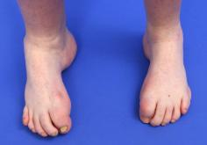
Figure 1A. Pre-Operative Clinical Anterior Posterior Photograph: Clinical photograph of bilateral feet at initial presentation, notice the cavovarus foot deformity and contracture digits.
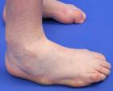
Figure 1B. Pre-Operative Clinical Lateral Photograph: Clinical photograph of right foot, notice the calluses on the lateral boarder of the foot.
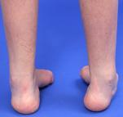
Figure 1C. Pre-Operative Clinical Axial Photograph: Clinical photograph of bilateral feet at initial presentation, notice the significant hindfoot varus deformity on the right.
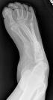
Figure 2A. Pre-Operative Anterior Posterior Radiograph: Anteriorposterior weight bearing view radiograph obtained at initial presentation with a talo-first metatarsal angle of 67°.
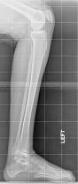
Figure 2B. Pre-Operative Lateral Radiograph: Lateral weight bearing view radiograph of the right foot at initial presentation with a Meary’s angle of 10° of cavus.
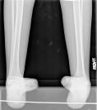
Figure 2C. Pre-Operative Axial Radiograph: Weight bearing hindfoot alignment views at initial presentation, right foot with a 20° varus deformity.

Figure 3A. Post-Operative Anterior Posterior Radiograph: Anteroposterior weight bearing view radiograph obtained 2 years posteroperatively. Note the normalization of the talo-first metatarsal angle.
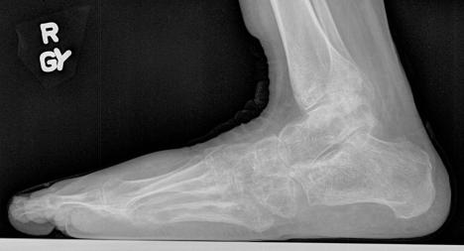

Figure 3B. Post-Operative Lateral Radiograph
Lateral weight bearing view radiograph obtained 2 years postoperatively

Figure 3C. Post-Operative Axial Radiograph
Hindfoot Alignment view weight bearing radiograph obtained 2 years postoperatively. Note the neutral calcaneal position of the both feet.

Figure 4A. Post-Operative Clinical Plantar Photograph: Clinical photograph of the right foot at 2 years postoperatively, notice the well healed linear plantar arch incision.

Figure 4B. Post-Operative Clinical Lateral Photograph: Clinical photograph of right foot at 2 years postoperatively, notice the reduction of the cavus foot.

Figure 4C. Post-Operative Clinical Axial Photograph: Clinical photograph of bilateral feet at 2 years postoperatively, notice the neutral hindfoot.

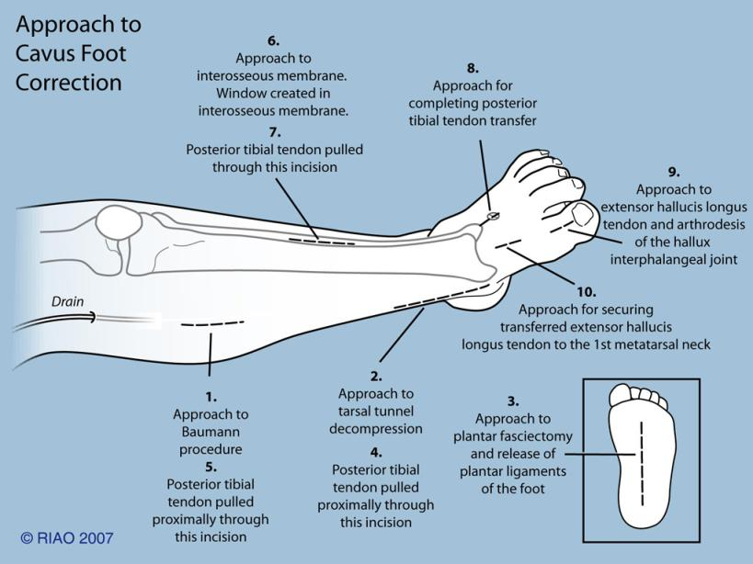

Figure 4. Illustration depicting the incisions required for comprehensive soft tissue reconstruction for CMT: Steps required for comprehensive soft tissue reconstruction

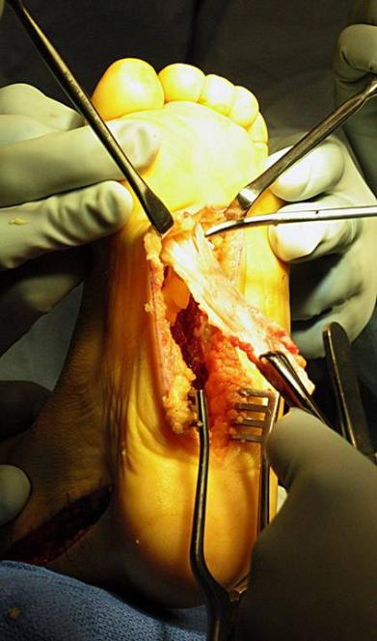

Figure 4a. Surgical image: Radical excision of the entire plantar fasica required for soft tissue reconstruction for CMT.

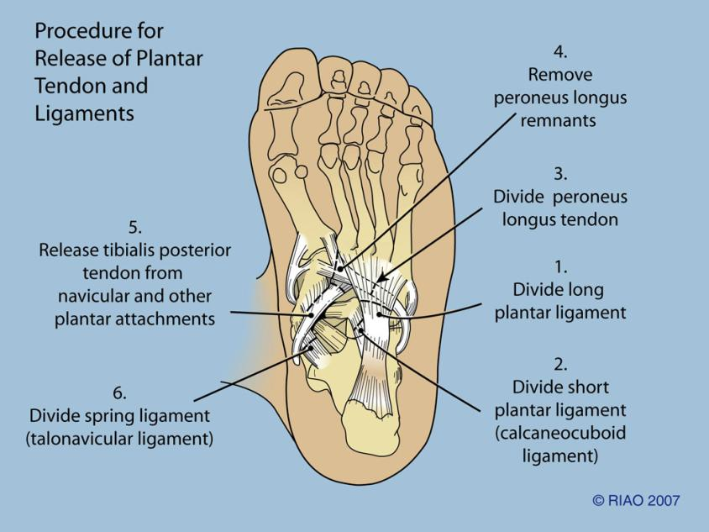

Figure 5: Procedures for release of plantar tendons and ligaments: Steps taken for the release of plantar tendons and ligaments

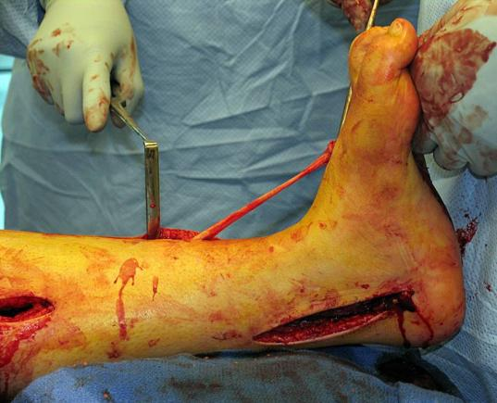

Figure 6: Surgical image of passing of posterior tibial tendon: Passing of posterior tibial tendon through the interosseous membrane prior to implantation into dorsum of the foot

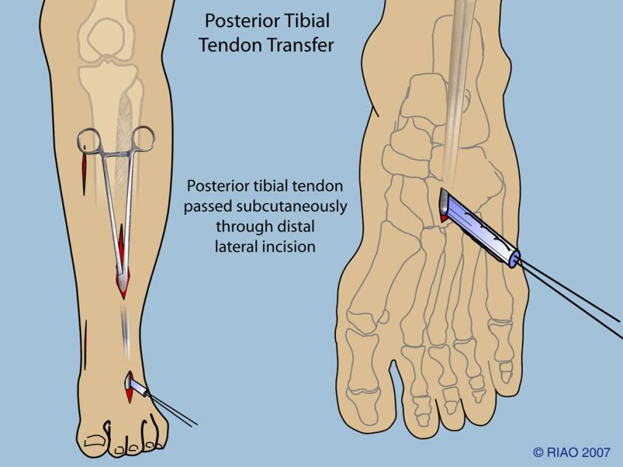

Figure 7: Posteror Tibial Tendon Transfer: Posterior tibial tendon passed subcutaneously through distal lateral incision.
Table 1: Demographics of Surgical Population
Demographics |  | CMT Group
Age at Surgery (years) |  | 16.0±13.8
Height (cm) |  | 152.2±22.4
Weight (kg) |  | 48.1±23.0
BMI |  | 19.6±5.5
Follow-up (months) |  | 32.5±28.6
Gender of Feet n(%) | male | 3(62)
Gender of Feet n(%) | female | 5(38)
Side n(%) | right | 3(38)
Side n(%) | left | 5(62)

Table 2: Radiographic Angles Pre and Post Operatively – Lateral View
Radiographic Measurement | Pre-Operative | Post-Operative | P-Value
Metatarsal pitch (n=8) | 31.4±11.1 | 17.9±6.1 | .008
Anterior distal tibial angle (n=8) | 86.4±5.4 | 86.8±2.7 | .768
Tibio-talar (n=8) | 118.1±22.0 | 115.5±16.3 | .810
Calcaneal pitch (n=8) | 25.9±10.8 | 12.8±11.4 | .004
Meary’s angle (n=8) | 13.4±12.2 | 10.1±17.7 | .728
Tibial -talar angle (n=8) | 62.5±12.0 | 71.0±16.6 | .075

Table 3: Radiographic Angles Pre and Post Operatively – Anterior Posterior and Axial Views
Radiographic Measurement | Pre-Operative | Post-Operative | P-Value
Talo-1st metatarsal (n=8) | 33.3±18.9 | 12.6±13.8 | .008
Kite’s angle (n=8) | 11.3±11.8 | 15.9±12.7 | .322
Engle’s angle (n=8) | 18.9±5.0 | 16.0±3.4 | .144
Hallux abductus (n=8) | 16.8±9.3 | 11.8±7.9 | .183
Tibial-calcaneal distance (n=5) | 49.0±9.4 | 6.6±9.4 | .003
Lateral Distal Tibial angle (n=5) | 99.0±7.4 | 87.6±4.3 | .030

